© Copyright ABB 2011. All rights reserved.

This document contains information that is confidential. It must only be used for the agreed purpose for which it is provided. The contents of this document must not be reproduced or distributed in whole or in part without the written consent of ABB or its authorised representatives.

Title | CC Modbus: User Guide
Distribution | Software Archive
Author | Greg Leach | Date | 2011-01-09
Review |  | Date
Approved |  | Date
Approved |  | Date
Remarks | User guide for reuse of Modbus Common Component.  Spring modified on 2nd April 2013 for 4-wire common component modbus

Contents
1 Introduction 3
1.1 Scope 3
1.2 Overview 3
1.3 Definitions, acronyms, and abbreviations 4
2 Design Summary 5
3 Integration of the Modbus CC 7
3.1.1 Project structure 7
3.1.1.1 Uppermost project structure 7
3.1.1.2 Interface folder 7
3.1.1.3 Uppermost “Source” folder content 7
3.1.1.4 “Layer 2” folder content 8
3.1.1.5 Uppermost “Layer 7” folder content 8
3.1.1.6 “Command Descriptors” folder content 9
3.1.1.7 “Register Tables” folder content 10
3.1.2 Coordinator level calls required 11
3.1.2.1 Initialisation 11
3.1.2.2 System execution 11
3.1.3 Files requiring manual customisation 12
3.1.3.1 Modbus.h 12
3.1.3.2 Modbus_Slave_Id.c 12
3.2 Suggested workflow following integration 13
3.2.1 Implement and integrate hardware layers 13
3.2.2 Generation of code and documentation 13
3.2.3 Customisation of slave id file 13
Appendix A: Component release package 14
References 15
Revision History 16

List of Figures
Figure 1: Modbus CC context within typical Common Framework instrument system 3
Figure 2: Expanded component subsystem context 5

Introduction

Scope
This document defines the steps necessary for reuse of the Modbus Common Component. See Figure 1 for context of the Modbus CC within a typical Common Framework based instrument system.

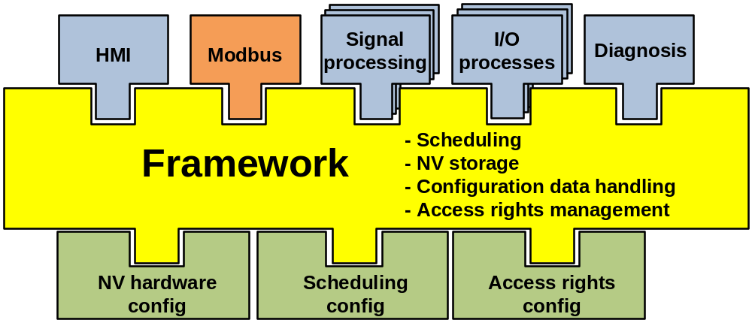
Figure 1: Modbus CC context within typical Common Framework instrument system

Overview
The Modbus CC provides a rapid means of adding a full implementation of Modbus to Common Framework based field devices.

A code generator is used to parse the pre-generated Common Framework CSV files, which in turn generates the Modbus subsystem application interface files (register tables). The code generator outputs documentation in HTML format which can be used by development staff for reference to the application interface. In addition to HTML and C source output, the access rights CSV file used as input for the ARM CC code generator can also be generated.

All Common Framework data-structures (single, array, structure, etc) are supported to provide as much flexibility as possible when creating the device specific interface. In addition to the standard (public) Modbus commands, private commands can also be defined that allow requesting of data without the inclusion of padding bytes necessary when eight-bit data is requested via public commands.

Definitions, acronyms, and abbreviations
Term | Definition
Application | The core functionality of a field device. For an instrument this would include operations such as measurement and signal processing.
CC | Common Component
Coil | Modbus data format used to represent a Boolean data-type. Up to eight coil values can be packed into a single message byte.
Common Component | Hardware and / or software component intended for reuse either as a design pattern that is customised for the dependencies of a specific target or as a drop-in requiring no customisations.
Common Framework | Software framework defined by ABB BU Measurement Products that specifies a common interface between software subsystems for data object access and execution of subsystem activities.
CSV | Comma Separated Variable. File format that defines a custom two-dimensional array of variables using comma characters (or semi-colon depending on region) as delimiters within each row.  Files of this format usually have the extension “.csv”.
Public command | Modbus commands where the format of the request and response is defined by the Modbus protocol specification.
Register | The second of the two available Modbus data types (see Coil). A register consists of a sixteen-bit word of data, and is the minimum amount of data that can be transferred by register-based Public Modbus commands. If eight-bit data is requested, for example, a register is returned, with the upper byte not being used. For a four-byte floating-point parameter, two registers are returned.
Register table | Table of indexes defining the address at which device parameters can be accessed via Modbus commands. The indexes do not imply the internal organisation of the parameters being accessed.
Slave | Device that responds to requests from a master.  On a fieldbus network this refers to measurement sensors, control actuator devices etc.
T_DATA_OBJ | Abstract software class defined by the Common Framework for data accessed across subsystem interfaces. Specialised for different types of data object.
T_UNIT | Abstract software class defined by the Common Framework for subsystem interface objects. Specialised for each subsystem.

Design Summary

The Modbus Common Component was developed with two main goals.

- Provide a Modbus interface to Common Framework based devices.

The Common Framework defines a clear interface for accessing subsystem data objects (T_DATA_OBJ). This in turn allows the use of automatic code generation tools to avoid error prone manual creation of interface files.

- Decouple the application layer from any hardware dependencies so only the low level communications components are project specific.

Each project may have different hardware requirements, eg, RS485, RS232, IrDA, TCP/IP, etc. By avoiding close coupling of the layers of the Modbus subsystem, only the low level communications drivers need be customised by the device developer.

Figure 2 shows the Modbus CC in an expanded context diagram.

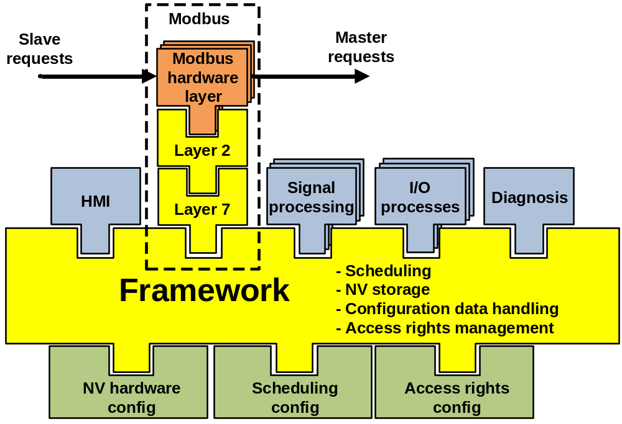
Figure 2: Expanded component subsystem context

The Modbus subsystem can be clearly divided into three layers.
Layer 7 | - The application interface. All generated files reside at this level. No customisation of the core code is intended to be performed, and is usable as is upon delivery.
Layer 2 | - Interface to the “Hardware Layers” that interact with device specific hardware. As with Layer 7, no modification to the core code is required for use in a new development.
Hardware Layers | - Interact with device specific hardware, and the only part of the Modbus CC where development is required. All sending and receiving of Modbus message data is performed at this level, only complete messages are passed to and from the hardware layers.

Integration of the Modbus CC

The following sections detail the steps required in integrating the Modbus subsystem in a Common Framework based project.

Project structure

The following is the suggested structure for including the Modbus subsystem files in a target project. Note that the files contained in the ‘Hardware Layer’ folder reside in different physical folders from the Modbus files.

Uppermost project structure

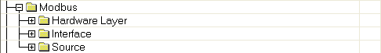

A folder “Hardware Layer” is used to hold the hardware layers in use by the project. The source and interface files are held in the “Source” and “Interface” folders respectively.

Hardware layer folder
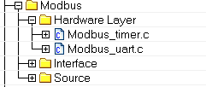
The folder include the hardware related files ”Modbus_timer.c” and “Modbus_uart.c”.

Interface folder

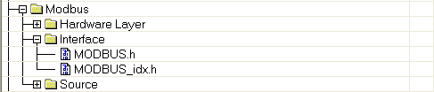

The Modbus subsystem interface files, “Modbus.h” and “Modbus_Idx.h” reside in the “Interface” folder.

Uppermost “Source” folder content

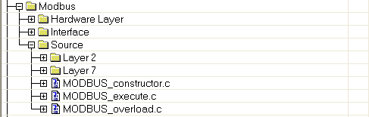

The Common Framework files of the Modbus subsystem reside in the “Source” folder. Two sub-folders, “Layer 2” and “Layer 7” are used to hold files associated with Layer 2 and Layer 7 activities.

“Layer 2” folder content

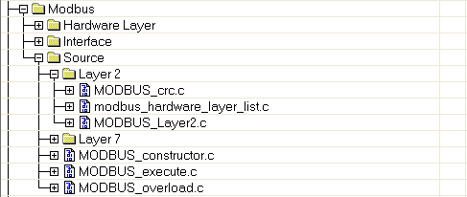

The Modbus Layer 2 files “Modbus_Crc.c”, “Modbus_Hardware_Layer_List.c” and “Modbus_Layer2.c” reside in the “Layer 2” folder.

Uppermost “Layer 7” folder content
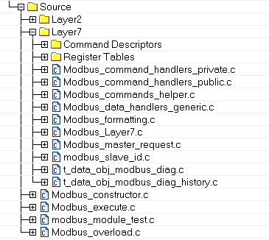

This uppermost folder also includes the “t_data_obj_modbus_diag.c” and “t_data_obj_modbus_diag_history.c” files. These two object types are created for diagnosis alarm object and diagnosis alarm history object in order to change the bit style object to byte style object.
Two sub-folders, “Command Descriptors” and “Register Tables” are created within the “Layer 7” folder. The upper-level Layer 7 files reside in the root of this folder.

“Command Descriptors” folder content

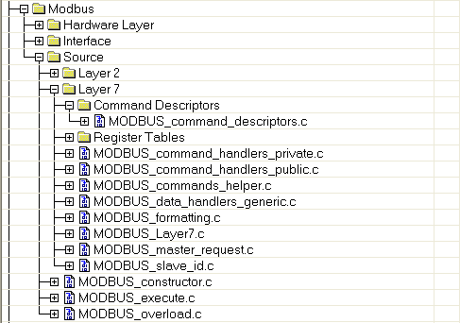

The “Command_Descriptors.c” file resides in the “Command_Descriptors” folder.

“Register Tables” folder content

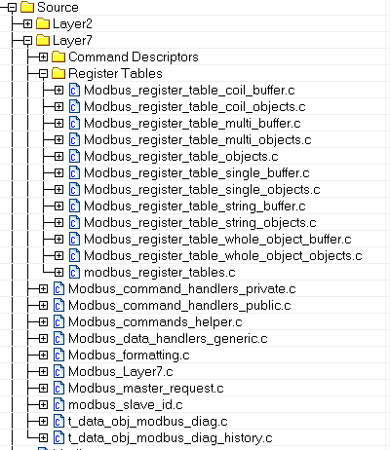

Files associated with accessing the device register tables reside within the “Register Tables” folder.

Coordinator level calls required

Initialisation

Before the main application loop starts, the Modbus subsystem must be initialised with a call to the Common Framework “Initialize” method.

This initialization will also initialize the hardware layer.

System execution

During execution of the system, the Modbus “UpdateEXE” method must be called to process incoming and outgoing messages.

It is also recommended that the thread in which the Modbus subsystem executes is updated as frequently as possible in order to allow timely processing of messages.

Files requiring manual customisation

Modbus.h
The enumeration, “TModbusHardwareLayerId”, is used to store a unique identifier for each hardware layer registered with the Modbus subsystem.

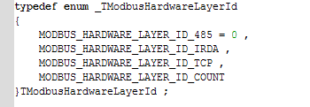

This should be customised by the device developer for the system, such that each hardware layer has a unique identifier. This identifier is passed by the hardware layer to the Modbus subsystem during registration.
In 4-wire common topworks project, only one hardware layer exists.

Modbus_Slave_Id.c

As agreed with all BUs, the Modbus Command “Get Slave Id” returns device information in a defined format. This allows DTMs developed in India to display Modbus device information in a common way.

The function “ReportSlaveIdHandlerModbus_Command_Handlers_Public” is called by the Modbus subsystem during processing of the Get Slave Id request. A buffer, pMessage, is passed by the caller, with the length of the data added to the buffer returned. Up to 240 characters can be added to the message buffer. The fields defined in the following sections must be filled in by the device specific implementation in the modbusSlaveId[ ].

Byte 0 – Manufacturer Id

Byte 0 of the message buffer must be set to the manufacturer id of ABB. This is the same used for HART and PROFIBUS devices, 0x1A.

Byte 1 – Unique device type code

Byte 1 is set to the single-byte unique device identifier code.

Byte 2 -- Software revision (optional)

Byte 3 -- Hardware revision (optional)

Byte 4 -- Serial Number (optional)

Byte 5 to 7 inclusive – Reserved for future use

Bytes 5 through 7 inclusive are reserved for future usage, and should be set to 0x0.

Byte 8 to 239 inclusive – Unique device descriptive text

The remaining bytes in the message buffer are set to a string describing the device, eg, “ABB CORIOLIS”.

Suggested workflow following integration
After the integration of the Modbus CC in the target project, the following is the suggested workflow in achieving operation of the Modbus communications.

Implement and integrate hardware layers

Several hardware layers are available for the Modbus CC (RS485, interface with IrDA) which may be usable with some modification to microcontroller peripherals, etc. If a new solution is required, the hardware layers should be developed following the same design pattern. As hardware layers are added to the project, unique identifiers must be created (refer to 3.1.3.1).

Generation of code and documentation

The Modbus CC code generator, ModbusGen, should be used to generate the application interface. The register Command Table should be generated at the same time. Detail information please refer to “ModbusGen - User Guide.doc”.

Customisation of slave id file

The device slave id response should be created (refer to 3.1.3.2).

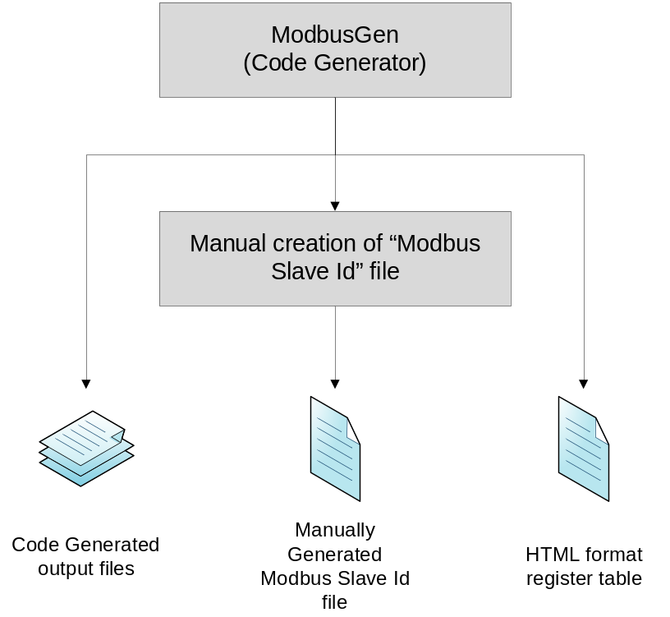

Coordinator caller

Take reference to 3.1.2.
Appendix A: Component release package
The Modbus CC for 4-wire common topworks release package consists of the hardware layer, the Layer 2 and Layer 7 files, with all associated documentation and tools for use. These should be unzipped to the root of the target project.

Following are the release package list
Item | content | function
Hardware layer | Modbus_timer.c/h  Modbus_uart.c/h | Implement the Modbus subsystem hardware interface
Layer2 | Modbus_layer2.c/h  Modbus_hardware_layer_list.c/h  Modbus_crc.c/h | Execute the layer2 and the hardware register management
Layer 7 | Modbus_layer7.c/h | Execute the layer7
 | Modbus_slave_id.c/h | Manage slave id string.
 | Modbus_formatting.c/h | Manage the Modbus data format
 | Modbus_master_request.c/h | Process Modbus master request.
 | Modbus_data_handlers_generic.c/h | Common data handler entrance
 | Modbus_commands_helper.c/h | Modbus command interpreter
 | Modbus_command_handlers_public.c/h  Modbus_command_handlers_private.c/h | Modbus command process
 | modbus_command_descriptors.c/h | Modbus command descriptor
 | modbus_register_tables.c/h  Modbus_register_table.h | The register tables and register-object definition
 | Modbus_register_table_objects.c/h | Check access rights
 | Modbus_register_table_whole_object_objects.c/h  Modbus_register_table_whole_object_buffer.c/h | Whole_object type register process
 | Modbus_register_table_string_objects.c/h  Modbus_register_table_string_buffer.c/h | String type register process
 | Modbus_register_table_single_objects.c/h  Modbus_register_table_single_buffer.c/h | Single type register process
 | Modbus_register_table_multi_objects.c/h  Modbus_register_table_multi_buffer.c/h | Multiple type register process
 | Modbus_register_table_coil_objects.c/h  Modbus_register_table_coil_buffer.c/h | Coil type register process
 | T_data_obj_modbus_diag.c/h | Modbus convert of t_data_obj_diag
 | T_data_obj_modbus_diag_history.c/h | Modbus convert of t_data_obj_diag_history
Common frame work interface | Modbus_execute.c/h  Modbus_overload.c/h  Modbus_constructor.c  modbus_module_test.c/h  Modbus _attributes.h  Modbus.h  Modbus_idx.h | Common Framework interface
Modbus docs | 4WCTW_Modbus Slave Subsystem Requirement Specification V1.1.doc | Requirement specification
 | 4WCTW Modbus Slave Subsystem Design Description V1.2.doc | Design description
 | Modbus subsystem Validation test.xlsx | Validation test plan and result
 | CC Modbus - User Guide.doc | User guide
 | ModbusGen - User Guide.doc
 | HvPvM - User Guide.doc
Modbus tools | ModbusGen.exe | Modbus generator tool, generate register table, object definition, access right configuration, etc.
 | HvPvM.exe | Modbus functional test tool

References
Ref. | Document
[1] | Subsystem Entry Tool / Code Generator  ABB Minden, 2005
[2] | 4WCTW_Modbus Slave Subsystem Requirement Specification V1.1.doc
[3] | 4WCTW Modbus Slave Subsystem Design Description V1.2.doc
[4] | ModbusGen - User Guide.doc

Revision History
Rev. | Description of Version/Changes | Primary Author(s) | Date
0.1 | Initial revision. | Greg Leach | 2011-01-10
0.2 | Change the revision for 4-wire common topworks | Spring Zhou | 2013-04-02

